Introduction to NoSQL - Hardware Requirement

Contents

[Upgrade RAM to 8 GB 1](#_Toc411612860)

[How to check your PC RAM? 1](#_Toc411612861)

[IDC RAM Upgrade request 2](#_Toc411612862)

[Non IDC RAM Upgrade request 4](#_Toc411612863)

# Upgrade RAM to 8 GB

The document will help you to raise request to updated the RAM from 4 GB to 8 GB

# How to check your PC RAM?

Please check the RAM of your Laptop and Introduction to Hadoop need laptop or computer that had RAM of 8 GB

Navigation to Control Panel -> All Control Panel Items -> Systems

Machine generated alternative text: Control Panel  All Control Panelltems  System
Control Panel Home
4 Device Manager
4 Remote settings
4 System protection
I Advanced system settings
View basic information about your computer
Windows edition
Windows 7 Enterprise
Copyright © 2009 Microsoft Corporation. All rights reserved.
Service Pack 1
System
Manufacturer:
Model:
Rating:
Processor
Installed memory (RAM):
System type:
Pen and Touch:
ClO Technology Services
WKS81-0713
Windows Experience Index
Intel(R) Core(TM) i5-3320M CPU @ 2.60GHz 2.60 GHz
4.00 GB (3.88 GB usable)
64-bit Operating System
No Pen or Touch Input is available for this Display

# IDC RAM Upgrade request

Step

1: Login to <https://itsupporttools.accenture.com/itservices/>

2: Navigate to **workstation Support -> workstation Hardware Up gradation** 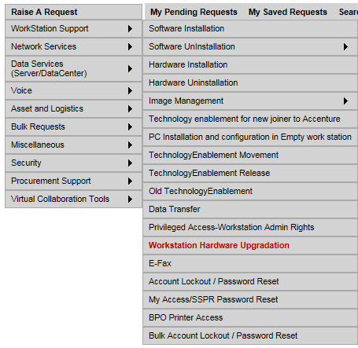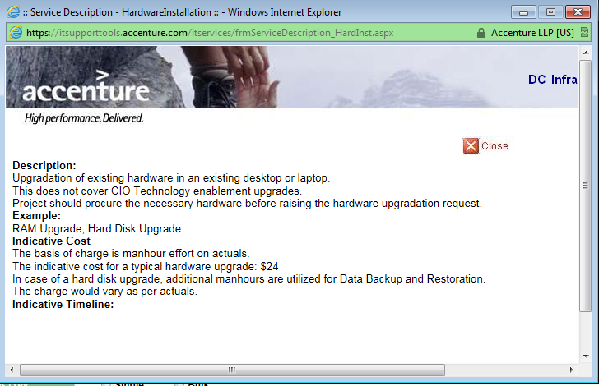

3: Fill in the required fields and request your supervisor to approve the request. The request is assigned to the procurement team.

Machine generated alternative text:
Click here to v,ew the mandatory fields
WORKSTATION HARDWARE UPGRADE REQUEST
Service Description
aiif.mansuri@accenture.com
I <—Select-->
10640874
Bangalore
I <—Select-->
•!1iiii geetanjalígoswami@ac .
arifmansuri
I xi
<—Select-->
xi
<—Select—>
xi
+918,386101000
<--Select—>
%,
r --
— —
-
Ex:8Am to 6Pm
_____________________________(lVo Of Characters Lefi
Submit Print Back
geetanjah.goswami
User Details
L
Note: Please indicate manager’s
Eli)
Supervisor Mad ID
Business Unit
]
Employee No.
Location
_] J Supervisor Name
Project Naine
For new project please contact CTSD
Charge Code
Facility
Request Details
OSingle OBulk
L

To know the status of your ticket call the **IT support 5555 option 3**

# Non IDC RAM Upgrade request

Please follow the steps:

1.       Go to <https://technologysupport.accenture.com/TechnologySupportHome.aspx>  >>>>>>>>>>>or [Technology Support Website](https://technologysupport.accenture.com/TechnologySupportHome.aspx)

2.       Click on **“Submit request”**

cid:image010.png@01CCF166.7206FAC0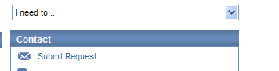

3.       Click on **“Purchase and Upgrades”**

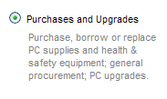

4.       Complete your **“Personal Details”**

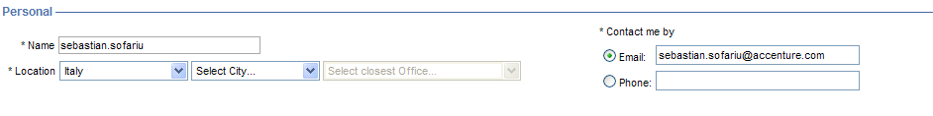

5.       Select **“PC Supply”**

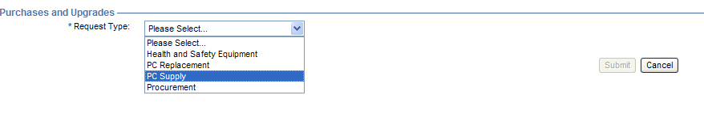

You have will have **3 options** :

cid:image006.png@01CC5782.494DC420

**Purchase :**

I require an **additional supply** item or component and I am willing to **pay for the supply**. This would include additional batteries, power supplies, cables, etc. for home, office, or  travel use. A **WBS element and an approver (manager or above) are required** for the purchase of an additional component.

**Borrow:**

|  |
| --- |
| I require a **loaner item** as I have lost, or left behind my cable, battery, power supply etc. I will return the supply to LTS when I am finished, and **will supply a WBS Element to be charged in case I do not return the item. If I return the supply item, my WBS Element will not be credited.**    **Replace:**  I require a supply item or component to **replace** one that is not functioning or appears to be defective. **To avoid charges, you must return the defective supply to LTS. WBS Element and a Manager or above Approval are required. WBS will be used only in case of a damaged supply back to LTS**.      6.       Please complete  the approval “field” --- >> can be your “Manager” or “Supervisor”  cid:image007.png@01CC5787.3481B920    7.       **Select the place where your item will be** delivered (the Accenture Office or the Address ),  the date (approximately) when you need the item    cid:image008.png@01CC5787.3481B920  8.       Select **the Item(s) you need and the WBS element** – see below    cid:image009.png@01CC5787.3481B920 |

**Note: For Participant in USA** Machine generated alternative text:
* Item(s)
E AC Adapter E Carry Case E Mouse E Security Cable
E AC Power Cord E LAN Cable E Keyboard [11 Other
E Battery
* Please Specify: ure the RAM 8 GB A
V
* WBS Element: _____________________________ J

Choose **others and specify the RAM upgrade required**

**WBS Element:** Use the training WBS on the course page. This is same as you use for training hours.